- Our sentiment data-based nowcast, developed with Penta, suggests UK employment growth has continued to slow in recent months. But as yet, there is no evidence that last month's increases in employers' national insurance contributions and the national living wage have triggered large-scale job losses.
- Our measure of labour market sentiment has stabilised at very low levels. The detailed results continue to suggest that firms are prioritising retention over recruitment, though encouragingly the score for expansion plans has progressively strengthened in the past six months.
- Our nowcast on pay suggests private sector regular pay growth will stabilise in Q2, rather than fall as the Bank of England anticipates. Given the Monetary Policy Committee puts a high weight on pay growth as an indicator of underlying inflation pressures, this is likely to reinforce the committee's caution around the pace of interest rate cuts.
It's a little over a month since the increases in employers' national insurance contributions and national living wage went into effect. Hard data on the impact is starting to emerge, but it will be several months before there's enough data to get a strong steer. And in any case, as we've frequently pointed out, there are major concerns about the accuracy of official data. So alternative data sources, such as our proprietary high-frequency sentiment dataset, developed in collaboration with Penta, are particularly important.
In our previous update in January, we noted that most sentiment measures had fallen sharply in H2 2024. Some of the fall pre-dated the October Budget, but the announcement of the NICs increase appeared to accelerate the deterioration in confidence.
Our latest update is based on sentiment data up to early-May and shows our headline measure of labour market confidence stabilising at the lowest level seen since we launched our indicator in mid-2016 (Chart 1).
Chart 1: Labour market sentiment has dropped to historically low levels
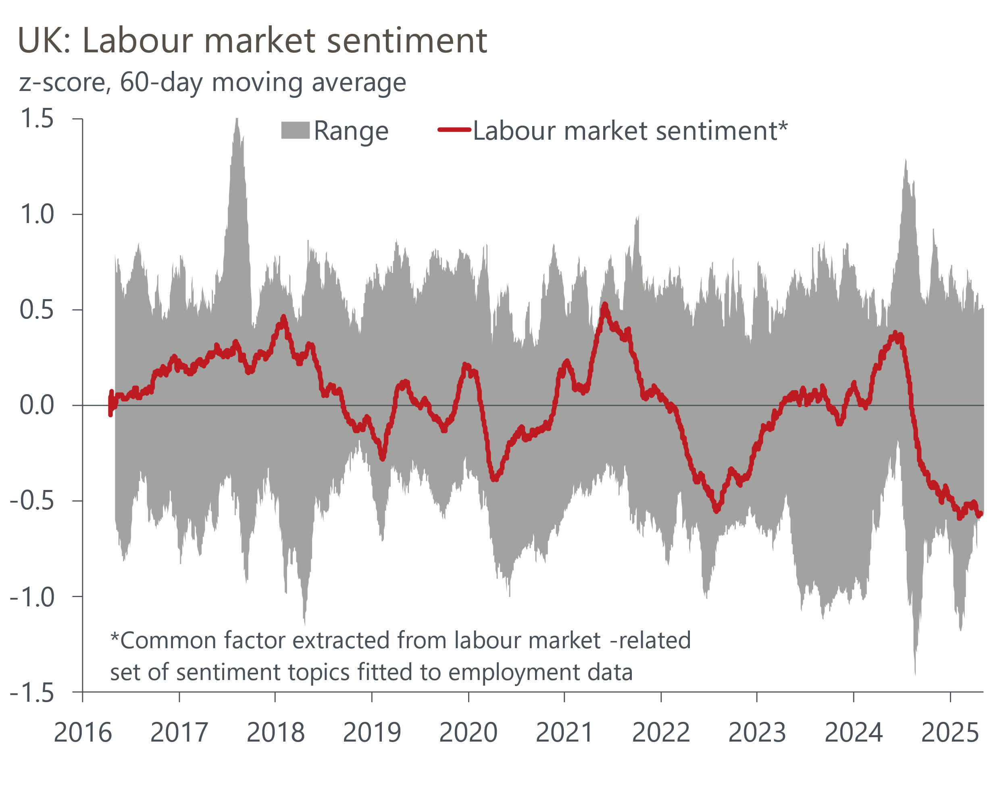
Sources: Oxford Economics, Penta

Drilling down into the individual components, the scores for jobs and recruitment remain well below historical norms, whereas talent and HR remains resilient. This suggests firms continue to prioritise retention of existing staff over new hires (Chart 2). This is consistent with the picture from official data, which shows redundancies remaining at relatively low levels and unfilled vacancies continuing to fall.
Chart 2: Firms still appear to prioritise retention over recruitment
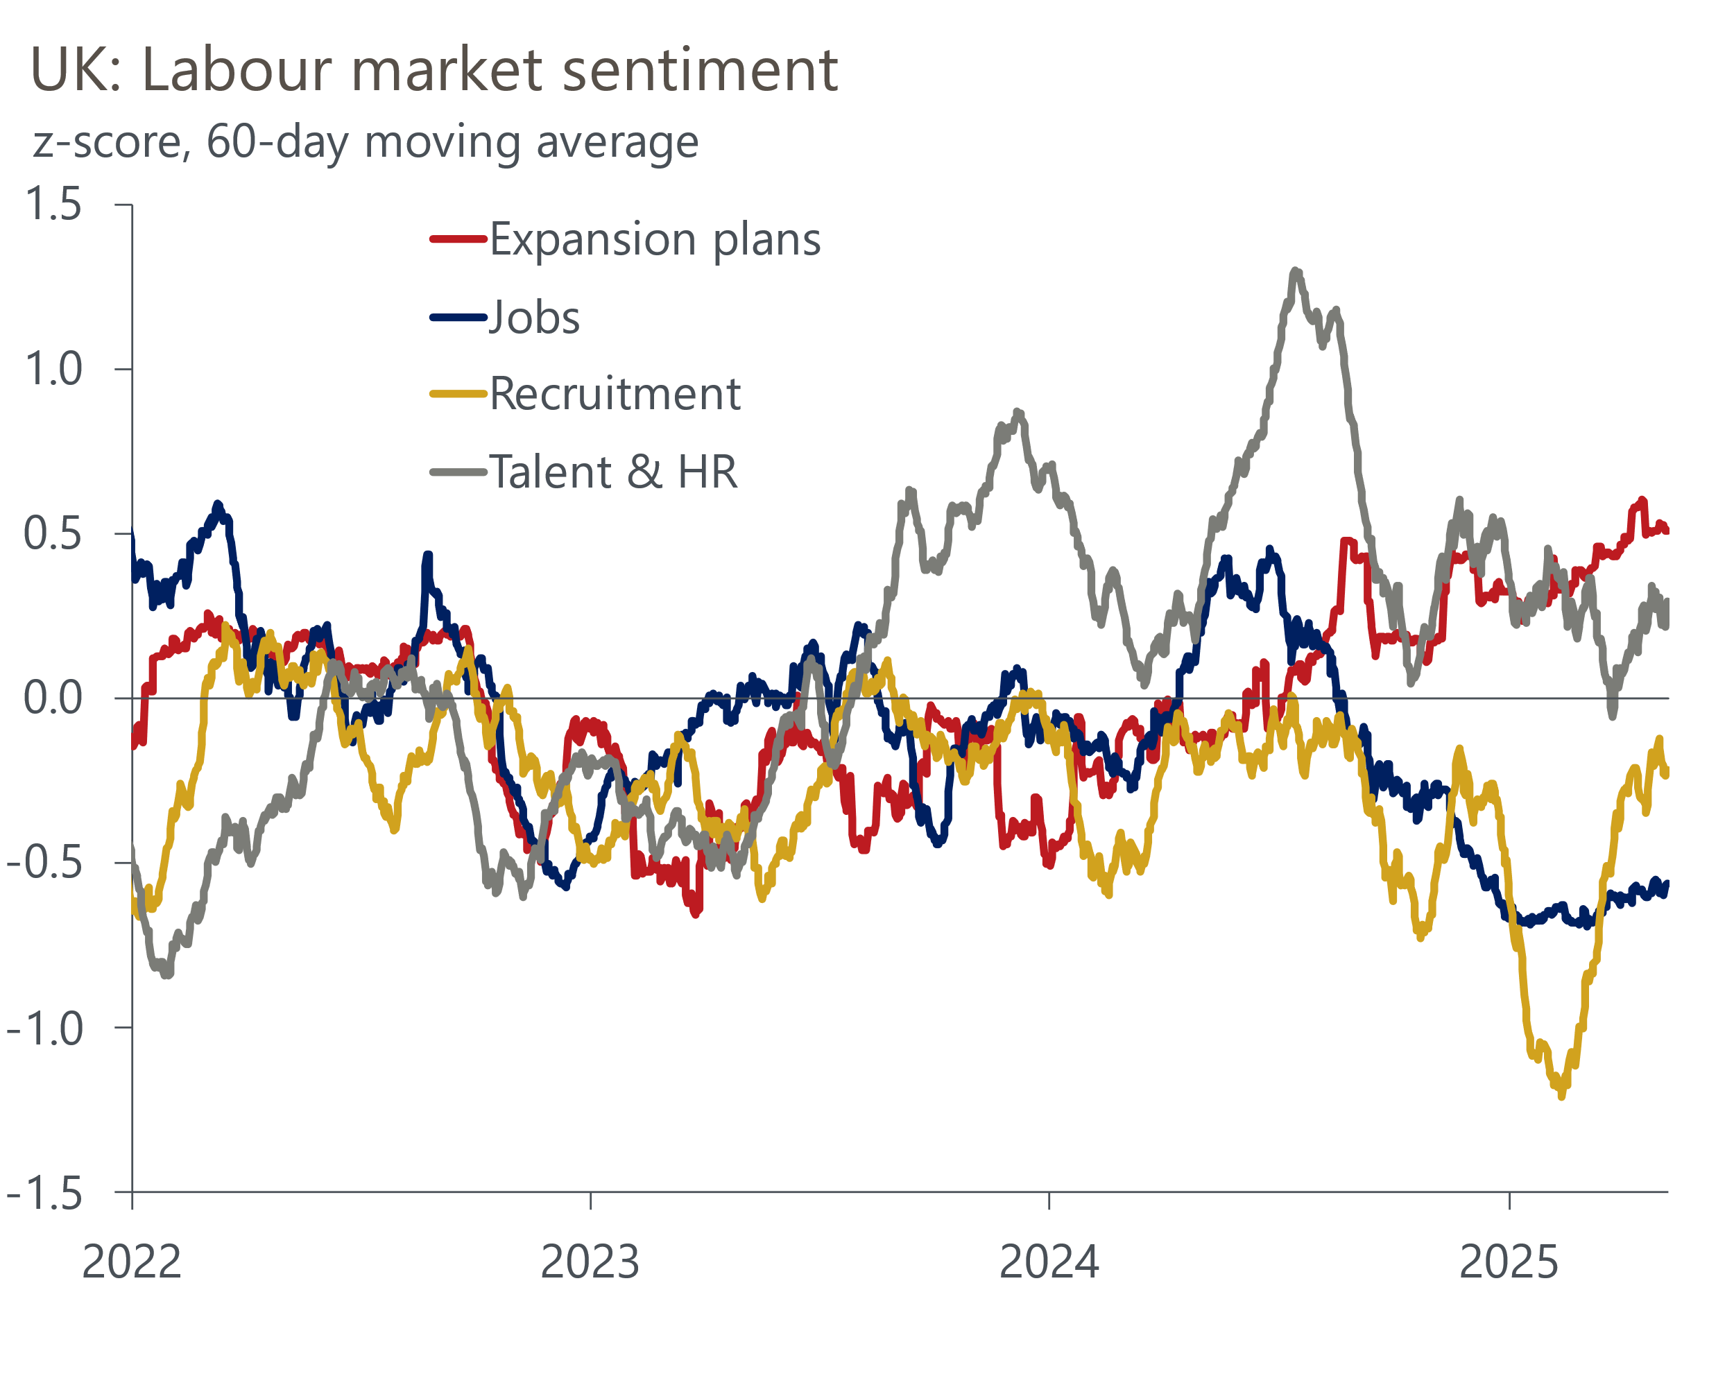
Sources: Oxford Economics, Penta
Still, the score for expansion plans has progressively strengthened over the past six months, suggesting that for some firms, the NICs increase hasn't been a major impediment to growth.

Nowcast shows employment growth is continuing to gradually slow
Our sentiment data-based employment nowcast suggests that jobs growth has continued to cool, with April's reading being the lowest since the pandemic (Chart 3). Our nowcast is slightly stronger than HMRC's count of employees on payrolls, though recently early HMRC estimates have tended to be revised up over time.
Chart 3: Our nowcast shows employment growth continuing to slow, but no big shakeout yet
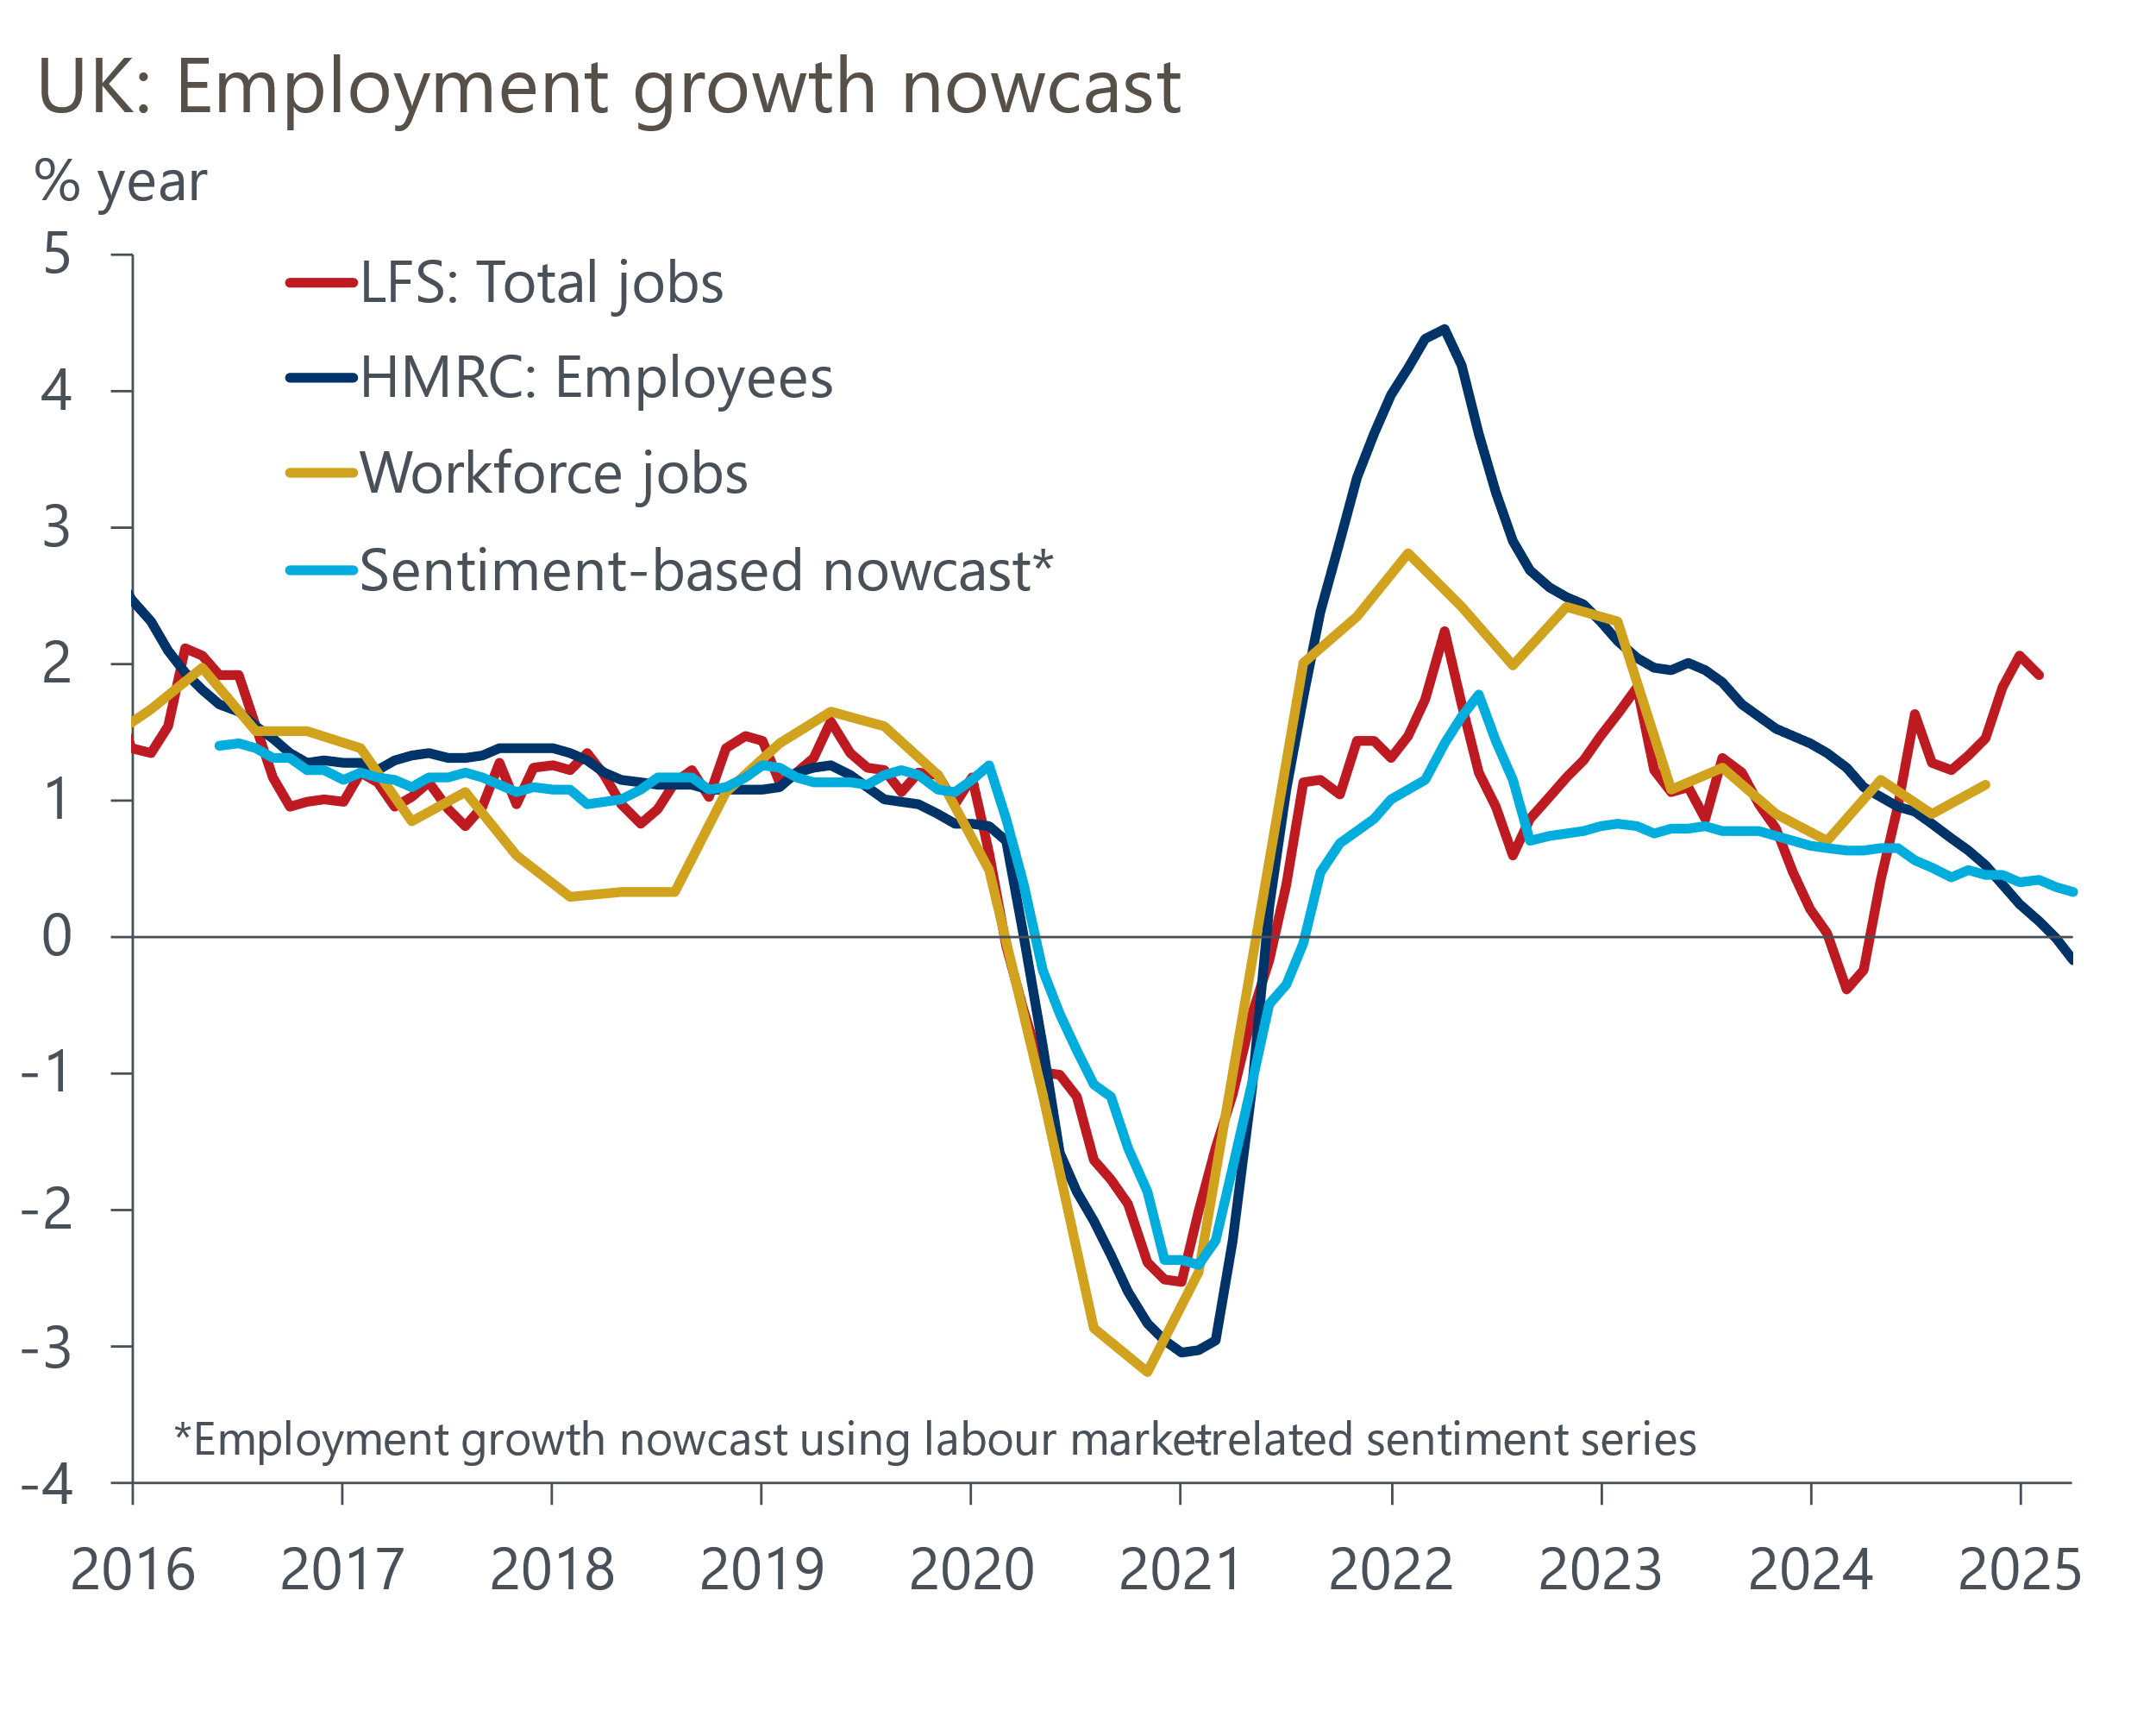
Sources: Oxford Economics, Penta, Haver Analytics
By contrast, our nowcast is much weaker than the latest data from the Office for National Statistics' Labour Force Survey. The ONS has recently trumpeted improvements in response rates and levels for its flagship labour market survey. But the LFS remains an outlier compared to other sources and its recent strength is very hard to reconcile with evidence from the wider economy.
Still, the news from our nowcast and recent HMRC data on the NICs impact is relatively positive. While momentum continues to ebb, we're not yet seeing the much deeper downturn in jobs that we thought could happen given the extent to which the increase in labour costs was focused on lower-paid roles and uncertainty around the ability of firms to absorb further cost increases.

Resilience in our pay nowcast will play on the MPC's supply concerns
The sentiment score for remuneration dropped to very low levels in the aftermath of the October Budget but rallied strongly in the early part of this year and is now just below historical norms. This is the opposite of trends in official pay data, which accelerated in late-2024 but in recent months has shown signs of losing momentum.
As a result, our sentiment data-based pay indicator points to slightly softer growth in private sector regular pay than the ONS measure in early-2025, at just above 5% rather than just below 6%. Our indicator is more in keeping with survey-based measures of wage inflation. Furthermore, our indicator suggests that pay growth is unlikely to slow in Q2, in contrast to the Bank of England's forecast in its Monetary Policy Report from May (Chart 4).
Chart 4: Our nowcast shows pay growth stabilising, not slowing as the BoE anticipates
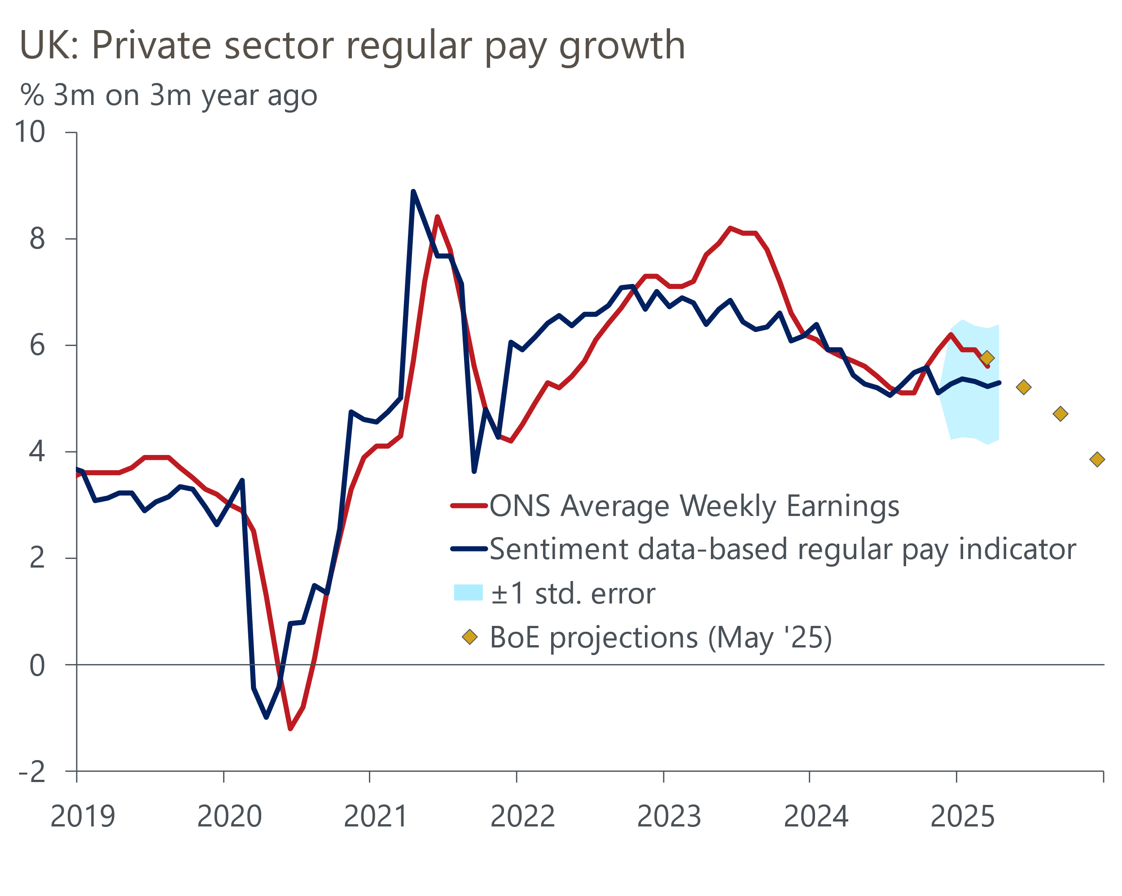
Sources: Oxford Economics, Penta, Haver Analytics
Over recent years, the Monetary Policy Committee has often used pay growth as a proxy for the strength of underlying inflationary pressures coming from the labour market, and has cited it as a key influence on their decision-making. We don't agree with this approach. The MPC's focus should be on setting policy to achieve the inflation target in a couple of years' time, and looking at past pay growth offers little relevant insight.
But it was apparent from the minutes of the May meeting and comments from committee members at the recent BoE watchers' conference that the pay data remains a key influence on their thinking. If – as our nowcast suggests – pay growth holds up, this is likely to encourage the majority of MPC members to maintain the cautious approach towards cutting interest rates that they've adopted so far.
So while we think the case for a more proactive approach to loosening policy is strong, we expect the MPC to continue cutting rates at alternate meetings for the rest of this year.

